**Climate Risks to US Telecommunications Infrastructure**

*A Holistic Report on Risks and Mitigation Strategies*

because we cannot hold back the oceans.

Kiran Wattamwar

Communications Law

Professor Susan Crawford

Fall 2018

**Executive Summary**

With researchers from more than 40 countries convening, the Intergovernmental Panel on Climate Change (IPCC) recently reported projections of an approaching version of the world in which climate change exceeds +1.5°[1]. Denoting specific ways in which a +2° increase in global temperatures could shock the world, the IPCC suggested that the following decade marks a critical inflection point on the magnitude of risks associated with climate change. This report projects a dire increase in sea level rise, an effect of the combination of melting ice caps, the reduction of water storage on land, and the thermal expansion of the ocean[2]. Among a projected uptake in natural disasters, the disruption of natural ecosystems, and several other consequences of climate change is the disruption of human systems and dynamics.

The looming threat of climate change to future generations of Americans has certainly warranted public response, made especially clear in the *Juliana v US* case which currently remains in legal limbo. The broad consequences of risks identified by the IPCC report, and the need for coordinated climate change mitigation and adaptation raise questions in the public sector about whether the government must seize a moral mantle and act in the best interests of future generations.

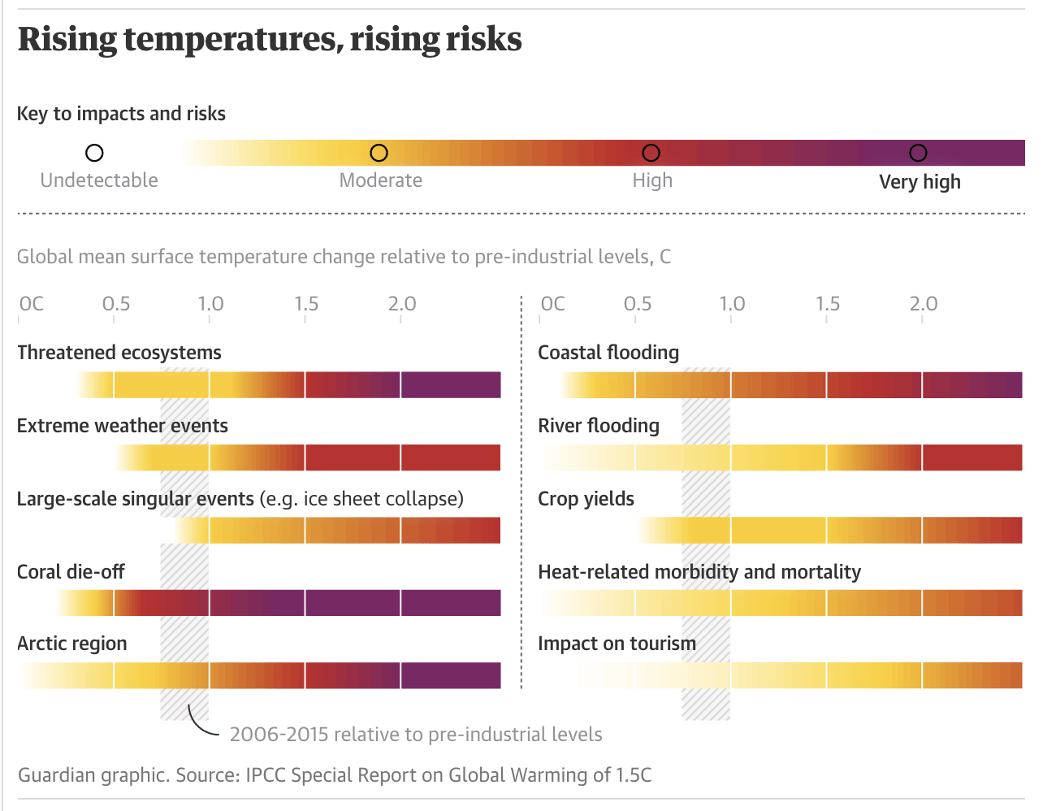

Infrastructure goes where people are, and inevitably, roads, highways, railways and bridges historically developed in clusters along coastal cities where much of the population has also clustered in the US. Included in this urban infrastructure are the pipes that underlie the Internet and telephony – wired communications, and Internet Exchange Points (IXPs). Paired together, the risks of sea level rise leave telecommunications infrastructure underwater in some of the biggest cities in the country, both literally and figuratively. We cannot hold back the oceans, but we can plan ahead. This paper considers Miami, Florida as the center of a case study in establishing a resilient and adaptive strategy to protect telecommunications, along with an overview of risks posed to telecommunications in lieu of the recent IPCC report.

**A primer on telecommunications infrastructure**

The technical architecture that powers our modern communications devices is multimodal, and geographically expansive. The internet is a network of networks, a web of wires that carries pulses of light encoding data to endpoints that can interpret it, and relay it to machines to route it to its final destination – your machine.

If you want to conduct a Google search, you might open a browser and initiate a request. The data from this request is broken down into small uniformly sized chunks, called packets, which compress information down in a digital format that can easily be transmitted. Of course, this data needs to reach a Google server to be acted upon. Your computer is connected to WiFi, and has a **Network Interface Cards** (NICs) in its hardware. NICs are components that allow computers to function as nodes in a network, both by cable and wirelessly. With an NIC, your computer can now participate in communicating with other nodes in the same network. Once your request data has been routed to a **Wireless Access Point**, it can be transferred via wire where the bulk of data transit happens at light speed. Over the wire, **switches** help transfer data between nodes within a network, and **routers** connect data between different networks altogether. At the end of the wire, the journey of this request continues, until it reaches Google’s servers and a response is issued back through the same pipeline.

Along the wired network are colocation facilities, Internet Exchange points (IXs), data centers and other points of presence (PoPs) that traffic data. Colocation facilities and data centers are primarily privately-owned properties housing stacks of servers, that can serve to decrease latency. These are usually leased or owned by private companies that rely on delivering services with high speeds over the internet. While many data centers and colocation facilities are strategically located in areas where the cost of power is low, they are also placed along high-traffic areas where geographic proximity lowers latency. Points of presence are more broadly intermediate points or terminal sections of wires in a network, and can be located inside colocation facilities.

Internet Exchanges (IXs) or Internet Exchange Points (IXPs) are also situated along the pipeline, but instead function to improve interconnection between different networks as neutral operators in favor of lower latency, more bandwidth, and reduced costs[3]. As such, they are critical to the current speeds of service offered, and without them, customers would experience nontrivial delays in service, especially felt in areas with poor long-distance connectivity. These usually intermediate the routing of data between different ISPs and CDNs, and are mediated by several companies and non-profit organizations. While private companies usually do not publicly disclose the locations of their colocation facilities and data centers, sites of IXPs are publicly known.

It is immediately clear that many IXPs are situated along the coast, with specifically large clusters in New York, Boston, Miami, Dallas, Seattle, and San Francisco. Because IXPs are a major site of the convergence of wires from different networks, these also mark critical points in private networks that are generally not accessible in public data.

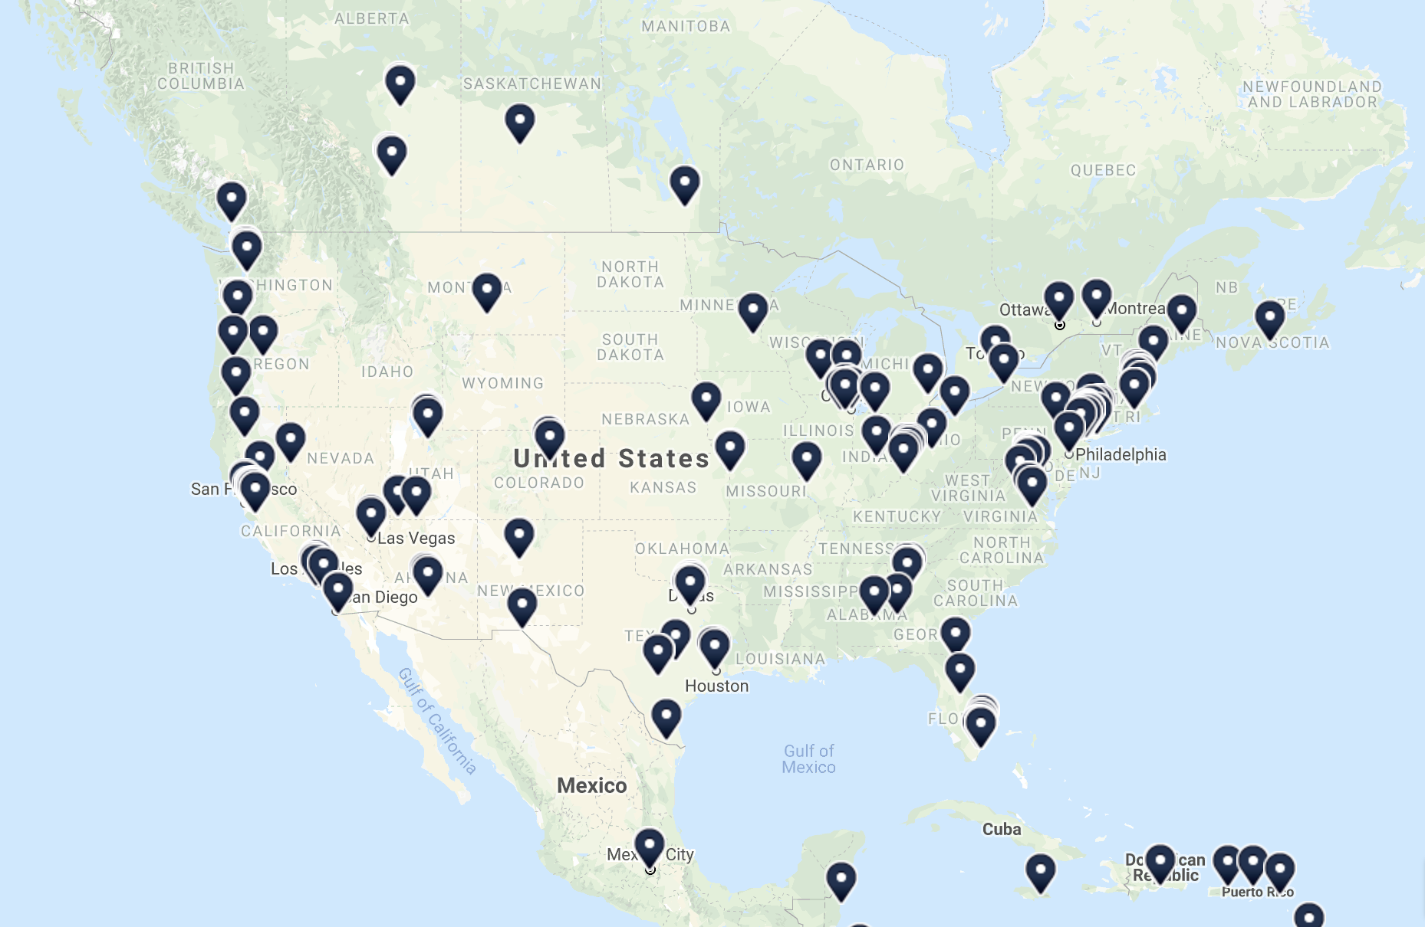

*While IXPs are geographically distributed across the US, major clusters of IXPs are located along coastal cities, most notably New York, Miami and San Francisco[4].*

Like IXPs, Content Delivery Nodes or CDNs also allow for lower latency data trafficking. CDNs are a distributed network of servers that can cache, or store data that is frequently accessed, across different geographic centers to accelerate the speed of data delivery to consumers with high availability (a saturated distributed network) and high performance (quick response times).

One CDN, Amazon AWS Cloudfront, which currently maintains 44.3% of the US market share[5], like IXPs, also clusters most of its services along US coastal cities based on this map from 2013, though the locations of its data centers are generally private.

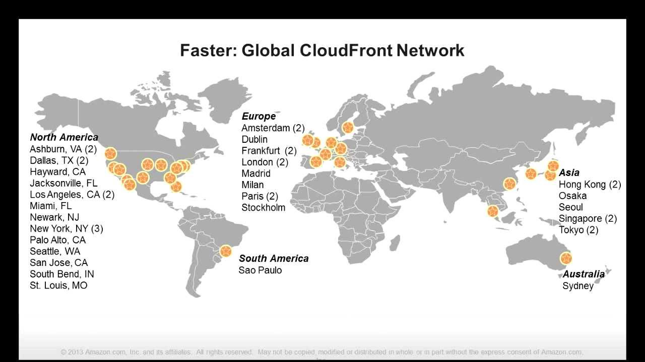

*Based on this 2013 presentation by Amazon, most of AWS Cloudfronts’ disclosed edge locations in the United States are planted along the coast[6].*

At the lowest level of this architecture are the wires in wired networks spanning large geographic areas that interconnect between CDNs, IXPs, and other digital layers of the communications pipeline. Within this information highway, wired connections bear the most critical role in moving data the farthest. These are called long-haul backbone fiber and underlie this network on a national and international scale. Between countries, international cables like the Transatlantic Cable also play a key role in moving data across oceans. While wire is the most essential intermediate in long-haul networks, it is also the most critical component of the last mile delivery of networks. Local loops of fiber, copper or wireless communications connect long-haul infrastructures (like IXPs, international cables, etc.) to their endpoints.

Wires and cables have historically served more than just internet data, underlying the architecture of telephony in the US, initially. In the late 19th century, single iron or steel wires were installed below ground and above the rooves of houses. As telephony matured, wires transitioned to copper cables for telephony systems and later, DSL. Modern wires are made of optical fiber strands that can transmit high loads of data at the speed of light, with low risks of noise in the data. With these significant benefits, fiber is typically the focus of new wired infrastructure while copper is being phased out. Because exposed wires risk introducing noise into data in transit, wires and cables are typically shielded by conduits. These conduits are physical layers that surround buried cables to protect them from environmental degradation, while decreasing noise and signal attenuation.

**Climate Risks and Impacts**

**General Climate Risks**

The “doomsday” report[7] published by the Intergovermental Panel of Climate Change discussed the risks of global warming of +1.5° above pre-industrial levels. Between 2030 and 2052, it identifies a +1.5° increase as highly likely based on projections from the current rate of warming. While this is a global risk, the report also states that warming greater than the global annual average is already taking place at specific vulnerable sites[8].

In this report, the IPCC identifies Eastern North America as one vulnerable site among others with medium to high confidence of risks like the warming of hot extremes (warm areas become warmer), increases in heavy precipitation, and more intense but less frequent tropical storms. Along with these climate risks are risks to man-made systems like transportation, energy and water. The report suggests that such systems built in the upcoming three decades will need to differ from those currently existing in Europe and North America if they are to adapt to these projected climate risks. Despite America’s stature as a developed country, its infrastructure too is at risk of critical failures when sea level rise meets its projections. Among its suggestions on mitigation strategies is the development of smart cities and smart grids to accelerate energy efficiency at the urban scale, and adopting “leapfrog” infrastructure in places where it has not already existed with less embodied energy and more sustainable design. While threats to telecommunications infrastructure are not directly addressed in this report, it is clear that such an infrastructure will need to improve in high-risk coastal areas to support other mitigation strategies that are raised.

The United States Global Research Program also recently published a report, its fourth National Climate Assessment[9]. In its reporting on coastal effects of climate risks, the NCA identifies that damage to coastal infrastructure like roads, bridges, tunnels and pipelines will result in “cascading costs and national impacts” because these provide “important lifelines between coastal and inland communities.” The role of such lifelines is consistent with the role of telecommunications infrastructure along the coast. Like the IPCC report, the NCA points out that cities along the East coast face risks of tidally driven flooding, storm surge, heavy precipitation, and coastline erosion. Solutions like environmentally based landscape design that preserve wetlands, and other porous natural features like estuaries, marshes and beaches may absorb water in cases of flooding and simultaneously remediate the surrounding environment.

The East coast of the US is the site of more than 49.4 million housing units and $1.4 trillion worth of homes and businesses[10]. Despite the climate, infrastructure, housing and private sector risks, current adaptation and mitigation plans focus on research and monitoring but have not generated major investments into rebuilding areas to be resilient to chronic climate risks[11].

In the United States, it seems that adaptation and mitigation strategies can best be summarized by an interest in increased monitoring and research, the development of sustainable infrastructure and planning, and an awareness of the long-term risks to the private sector and quality of life for residents in those areas. Solutions primarily are housed in development strategies and policy solutions to limit the US’ production of CO2 emissions. While ICTs are raised in both the ICPP and NCA reports, they are primarily included because of their role in smart connected cities that are more resilient to their chronic climate risks. Not once in either report are threats to communications infrastructure specifically raised. Despite this, it is easy to draw connections between major sites of telecommunications infrastructure and states that are vulnerable to the threats posed by climate change.

|  |  |  |  |  |
| --- | --- | --- | --- | --- |
| **Rank** | **States Ranked By Broadband Access[12]** |  | **Rank** | **States Ranked By Flood Risk[13]** |
| 1 | Connecticut |  | 1 | **Florida** |
| 2 | **Massachusetts** |  | 2 | Louisiana |
| 3 | Rhode Island |  | 3 | California |
| 4 | **New Jersey** |  | 4 | New York |
| 5 | Iowa |  | 5 | **New Jersey** |
| 6 | New Hampshire |  | 6 | Virginia |
| 7 | **Florida** |  | 7 | South Carolina |
| 8 | Maryland |  | 8 | North Carolina |
| 9 | Delaware |  | 9 | **Massachusetts** |
| 10 | Minnesota |  | 10 | Georgia |

*Rows marked in the lighter red indicate states on the East coast, and rows marked in the darker shade overlap between both tables.*

On the world stage, even the International Telecommunications Union’s *Information and communication technologies for climate change adaptation in cities* technical report, threats to communications infrastructure are acknowledged, but adaptation strategies to not address those threats. Instead, they focus on how ICTs can be useful in implementing other adaptation strategies[14].

The World Economic Forum’s 2018 Global Risks Report identified 30 global risks by their likelihood to occur and their impact among which extreme weather events, natural disasters, and man-made environmental disasters ranked highly along both axes[15]. Also included in this network of risks is the failure of critical infrastructure, and the breakdown of critical information infrastructure.

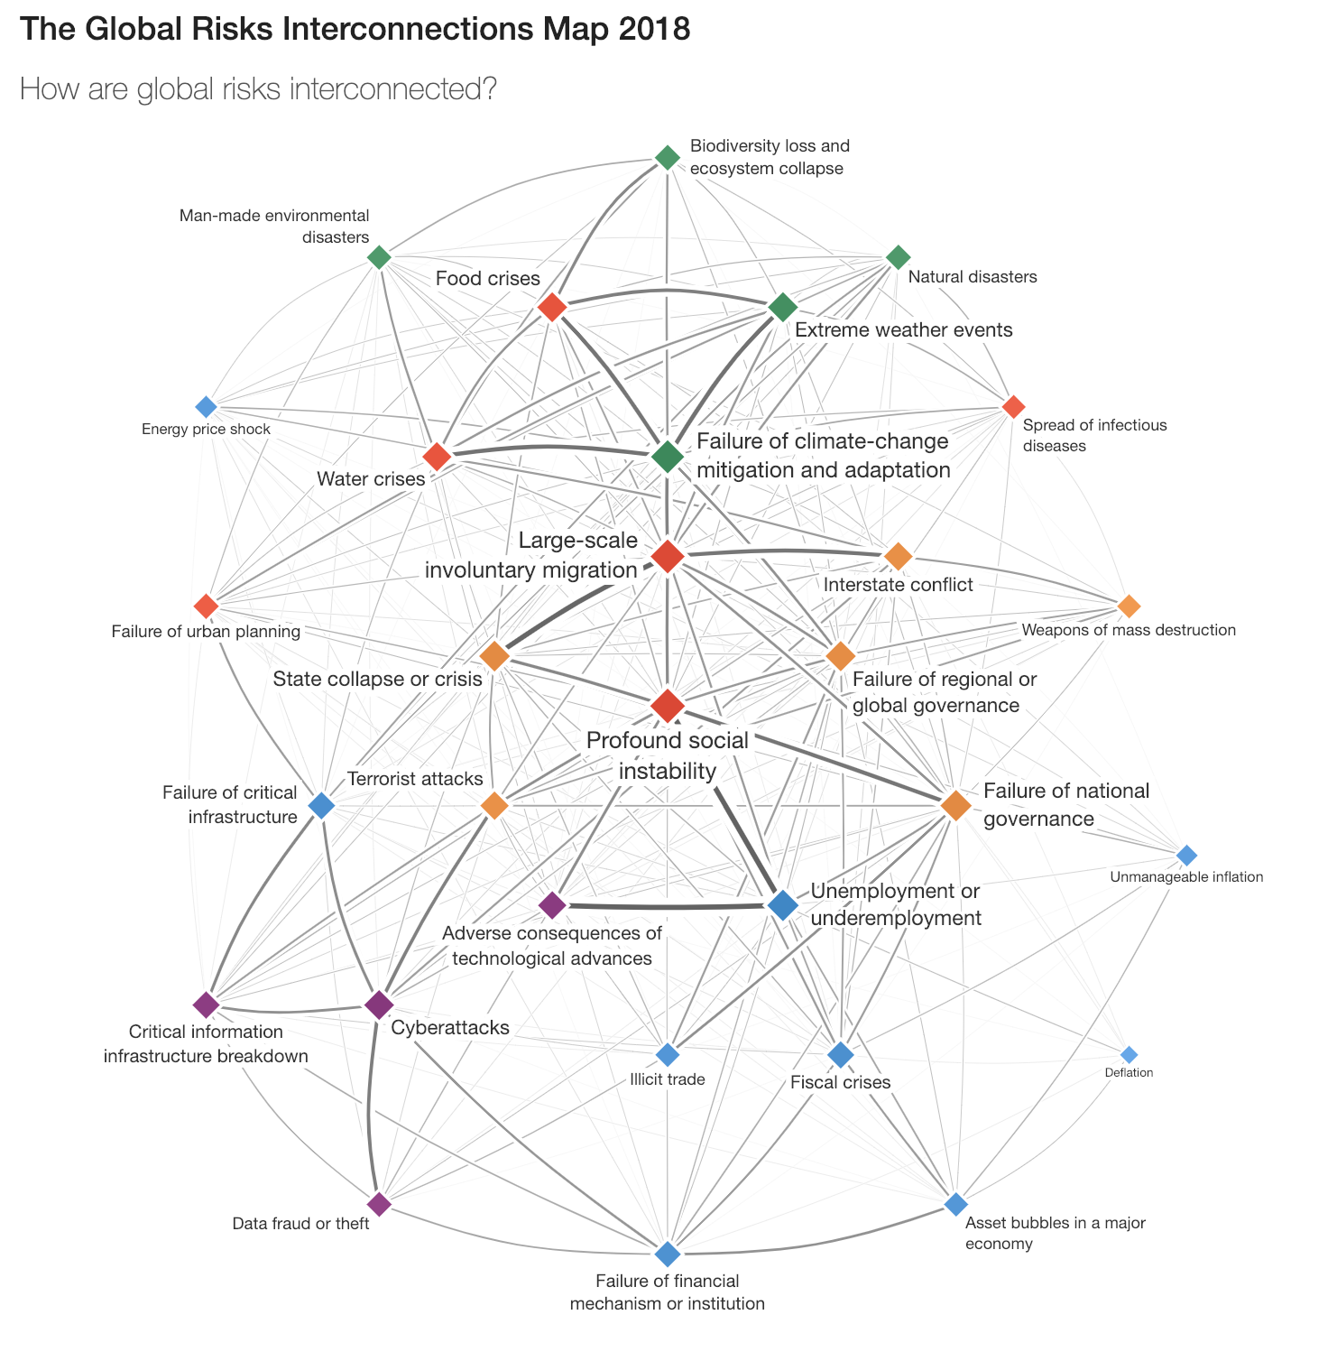

*The World Economic Forum’s 2018 Global Risks Report included several issues linked to failure of climate-change mitigation and adaptation, to which water crises, urban planning failures, and information infrastructure breakdown are linked* [16]

Whether telecommunications infrastructure is directly or indirectly implicated with imminent risks due to climate change, it is clear that the adaptation strategies offered by every report will require a performant and reliable underlying network, and that the rebuilding of other at-risk infrastructure will offer a chance to rebuild communications in the US, too, in the process.

**Climate Change Risks to Internet Infrastructure**

The climate change risks to internet infrastructure are broad, present and impactful. For its intermodal nature, degree of variety in its implementation, and complexity, this infrastructure’s risks are distributed across different elements of its network.

**Threats to Conduit, Buried Cable, and Fiber**

In 1857, despite two botched attempts to move cable protected by a layer of gutta-percha, a latex-based protective sheath, across the Atlantic Ocean, the third attempt resulted in a system that was able to transmit a congratulatory message from Queen Victoria to James Buchanan in which she expressed that she was “fervently hoping that the electric cable, which now connects Great Britain with the United States, will prove an additional link between the two places whose friendship is founded upon their common interests and reciprocal esteem.[17][18]” Though the cable failed in 1858, the technological development of sheaths and installation strategies have remained extremely similar to the developments that followed, including large similarities in the gold standard of wired infrastructure today. The first transcontinental telegraph line was installed in 1861 in the United States. The history of telecommunications in the US followed, laying backhaul cable across the country and allowing new models for data transport to emerge.

While the transcontinental telegraph line has long been out of operation for more than a century, many cables still in operation today that are heavily relied upon were installed more than two decades ago. Within these two decades, significant advancements in materials science and new modes of data transport (fiber optic cable, for example) came into commercial production, and became the new superior standards for wired networks. While DSL is not a major area of investment in the private sector, it boomed in the 1980s and 1990s, and it still remains a major service with more than 90% coverage in the United States[19][20]. Because copper cables were structurally already in place to serve incumbent telephone companies, emerging cable companies were lured to find ways to use these lines to transmit new kinds of data. Though developments in fiber and cable have outpaced DSL’s capabilities, DSL still has a presence (though, withering) in making the US more connected. Copper wires installed during this boom may not continuously be maintained, may not be insulated with materials that can handle consistent wet conditions, and still are a laggard in offering high speeds along both transmission and upload.

Fiber optic cables, today, are commonly installed via the process of microtrenching. In this process, small channels that are between 6-12 inches deep and 1.5 inches wide are dug by machines designed for the process. Hollow ducts are laid in the trenches and are joined at vaults where eventually, the cable that is fed through the ducts can meet other wired endpoints[21]. Because these trenches are generally shallow, their barriers are composed of a mixture of asphalt and concrete which is porous. The alternative to microtrenching is more expensive, and takes longer to implement. This technique involves generating 3-5 feet deep holes that can be used to bore other tunnels extending from it, under layers of concrete.

Because microtrenching is shallow, it presents some general feasibility issues that are relevant when considering the risks of climate change. If the ducts are not constructed with quality or the materials do not meet industry standards, water leakage is possible as chronic showers can definitely submerge shallow asphalt. Roads are also repaved cyclically, every 30 to 40 years. During this process, old paving is excavated as deep as 3 feet, and by this point, if there is limited data on the installation of microtrenches, road construction crews may not be aware of where specifically and how deep fiber cable is laid. Considering the risks of climate change to infrastructure alone, the reinstallation of roads may present as a sooner requirement of many dense population centers, and require care as previously installed fiber must be handled. This may also be seen as an opportunity to upgrade the cable available to places that are also upgrading their transportation infrastructure, though public private partnerships will to align on incentives during such an event.

Risks of recurrent flooding, increased precipitation and a rising intensity of cyclones and tropical storms raise the risk of water infiltrating through porous roads and pipelines. Generally, water, humidity and corrosion present the highest risks to cable, conduit and fiber. Water can fill cracks within fiber, and attenuate signals, causing the quality of data transfer to weaken. Water can accelerate corrosion, especially for materials that were not initially designed to protect against it. Signal loss may occur at connection points where wires are generally more vulnerable if not installed with care. Finally, water can freeze around conduit or fiber, and melt afterwards, leaving cracks. In general, this may lead to compressive forces that have permanent damaging impacts on backhaul and local wired networks. Aspects of cable were designed to protect against some slight weathering but were not meant to be submerged under water (though the Transatlantic Cable has successfully demonstrated that this was possible even in 1857, if designed for this particular use case).

An industry white paper measuring the impact of water on fiber[22] also confirms the risks of rising water on its own cables. Datwyler, a manufacturer of fiber optic cables mentions that there are two main industry standards for measuring the impact of water on fiber optic cables. The first are “damp heat” measuring tests, in which cables are exposed to humidity, and the second are tests in which cables are immersed in temperature controlled water. During both, signal attenuation is measured and there are industry standards for what is considered reasonable. Fiber manufactures do have fiber offerings that can stand against water in these scenarios, but the white paper still acknowledges water’s associated risks. Fiber optic cable that is damaged or stored without end caps may allow water to creep through the cable, and this kind of penetration can pose risks because the water can creep into closures or splice boxes, and cause irreversible increases in attenuation. Preexisting microcracks can enlarge over time “dramatically reduce fibre life.”

Datwyler continues to mention that “of course you can install a universal cable in dry ground. But who can guarantee that the moisture level will not rise – and with it the diffusion of water in the cable?” Outdoor cables can generally be split into two camps – those with high-density polyethylene (HDPE) sheaths and universal cable sheaths. HDPE is impermeable, and can prevent water diffusion from affecting what is below the sheath, while universal cable sheaths contain mineral additives that make it a more porous membrane that is not protectant against water-related risks. Datwyler’s white paper concludes with a recommendation not to bury universal cable directly in the ground or pipelines unless the systems are dry, and that “cable duct systems at risk of water penetration or in which there is permanent standing water” should use specially longitudinally watertight cables instead of standard offerings.

Last mile fiber can also be deployed above ground, and faces a different group of risks, primarily those associated with violent storms, high winds, and intense tropical cyclones, which are also identified as risks of climate change affecting the Southeastern coast of the US and Puerto Rico.

**Threats to Nodes, Local Exchanges and Points of Presence (PoPs)**

One undersea cable map scraped together from various public data sources also makes it clear that the East coast serves as a major site for interconnection along intermodal data transportation. Along with each of these undersea cables are endpoints, called landing centers, that must manage incoming and outgoing traffic, and because the load on these cables is expected to be high volume, the presence of undersea cables implies nearby exchanges. Though private sector data is inaccessible with respect to the location of its major infrastructural elements, publicly available data strongly suggests that non-wired infrastructure in US wired communications is heavily clustered along the East coast.

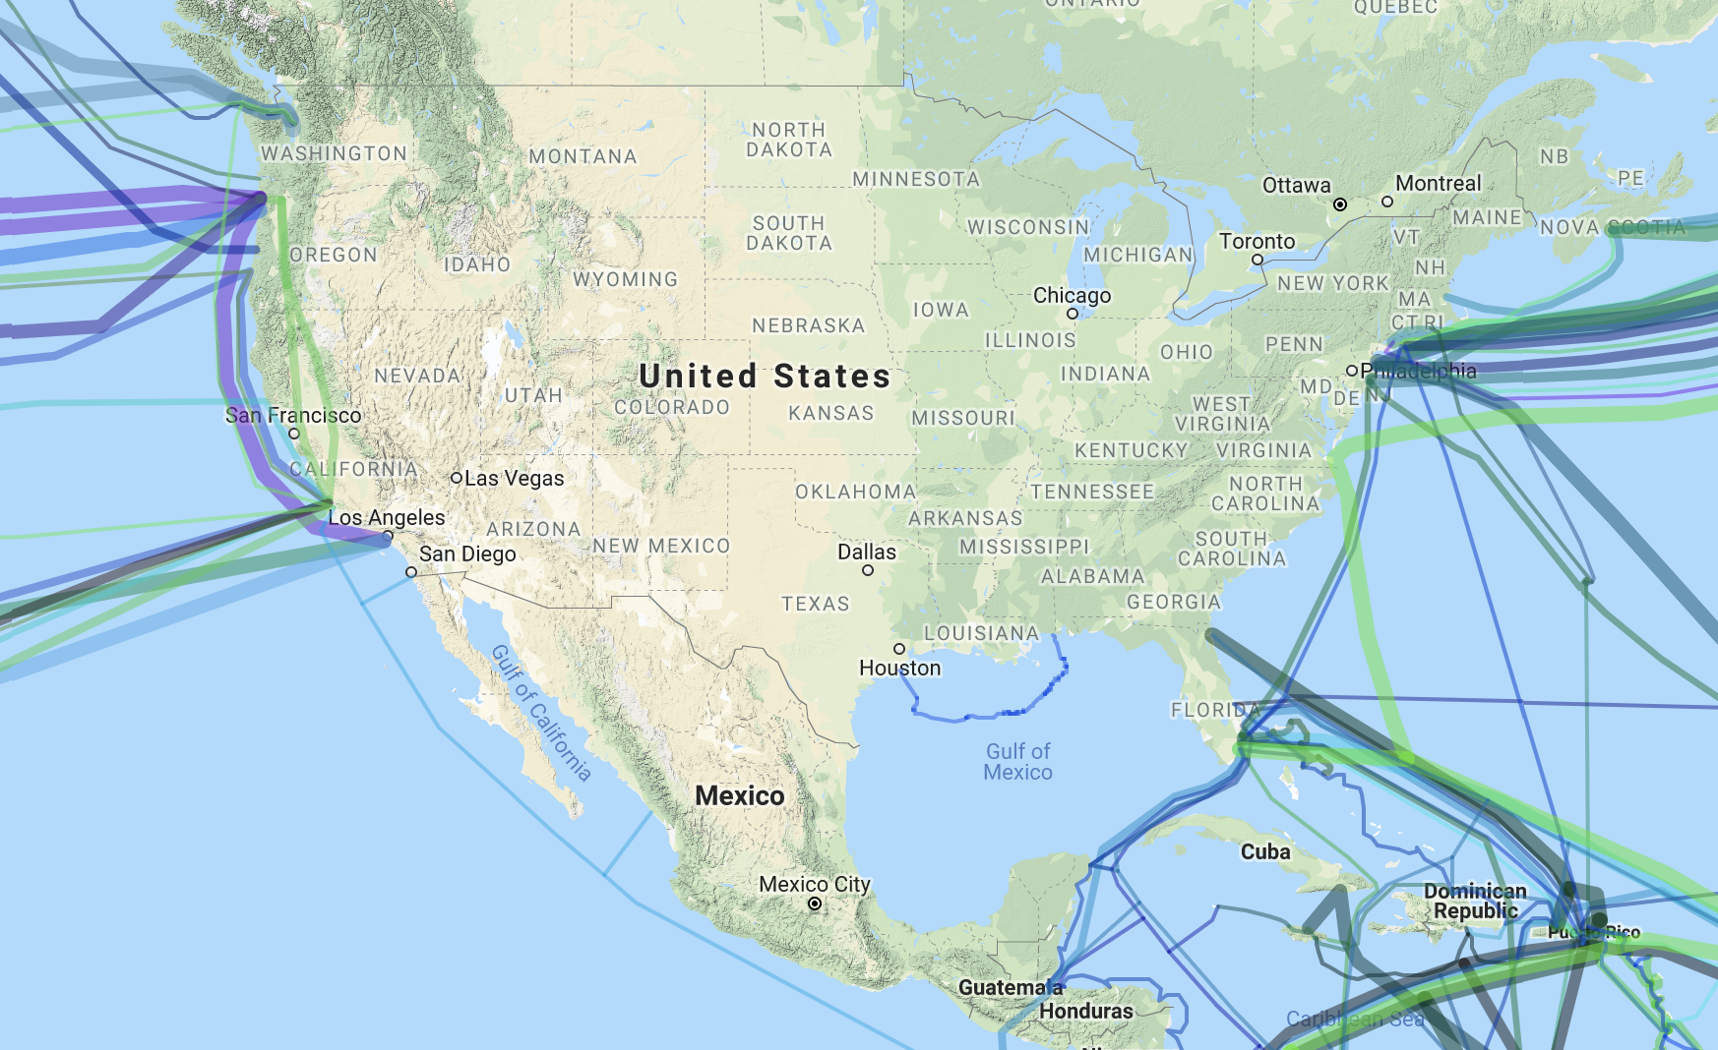

*Several undersea cables converge in Portland, San Francisco, Los Angeles, New York, and Miami which imply the presence of exchanges, called landing centers, to traffic this high volume of data[23].*

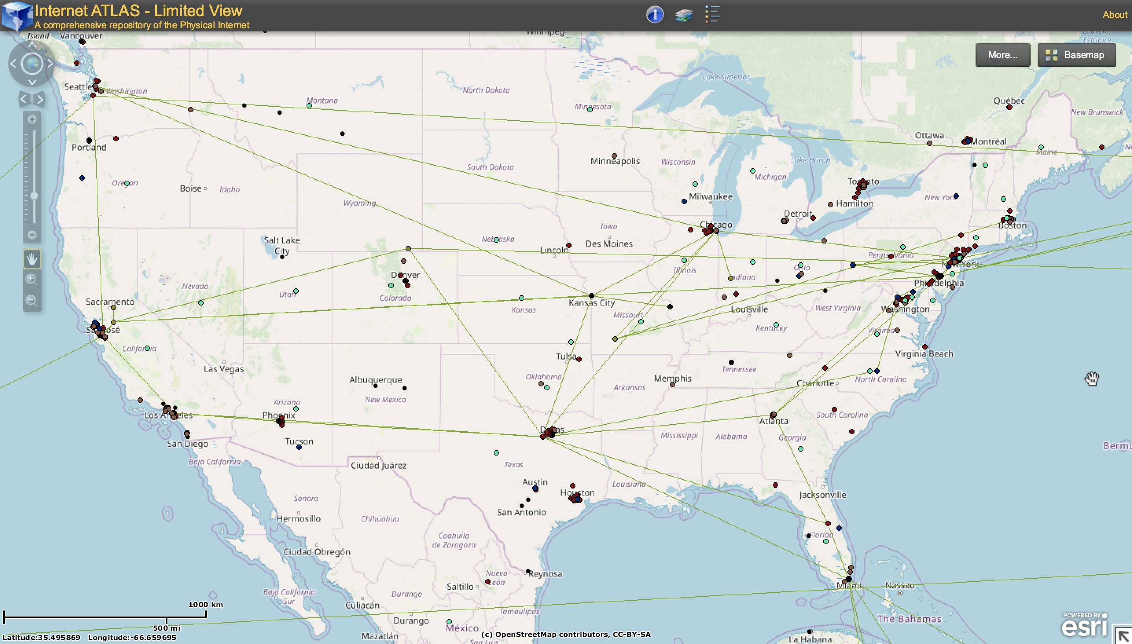

*A separate map identifies different elements of the Internet’s physical infrastructure, from the Internet Atlas. Clusters where IXPs and underwater cables are also clusters of other infrastructural elements like RIPE Atlas measurement endpoints, and Traceroute end points for research measuring internet traffic.*

As evidenced earlier by the map of internet exchanges, and content delivery nodes, higher level communications infrastructure is densely located along dense population centers, and coastal cities, especially those along the East coast, are vulnerable to climate risks. In an alarming report, researchers from the University of Oregon and University of Wisconsin-Madison identified that “4,067 miles of fiber conduit will be under water and 1,101 nodes (e.g., points of presence and colocation centers) will be surrounded by water in the next 15 years.[24]” Additionally, by pairing the NOAA’s projections of sea level rise and overlaying this geographic data with the locations of physical infrastructure, the same paper reports the following sites at a clear and present risk of flooding to their local areas and sites by 2030:

|  |  |  |  |
| --- | --- | --- | --- |
| **PoPs** | **Data Centers** | **Landing Stations** | **IXPs** |
| 771 | 235 | 53 | 42 |

While the threats to infrastructure that does not include submerged cable present a less obvious risk, and will express in terms of network degradation slowly, IXPs, data centers, landing stations and PoPs remain at risk, and mitigation strategies for the upcoming decades still remain important.

In general, there already exist solutions to both conduit/cable deployment and above-ground infrastructure that can be resilient against the risks of climate change, but the real challenge in mitigating risk and adapting will be in installing solutions at scale to actually ensure service as sea level rise exacerbates – this is not a technology problem as much as it is a policy problem to incentivize companies and communities to work towards this.

**Non-Infrastructure Climate Risks to Internet**

While long-haul cable moves data the farthest, information is often transmitted through the airwaves in its last journey from infrastructure to a consumer. By modulating the air at a certain frequency, and packing data along the waves generated using frequency or amplitude modulation, data can travel through the air and be received by a router, that goes on to communicate with your devices. But at high frequencies, these signals attenuate. With occlusions obstructing the path of the signal to routers, signal weakens. Fog, rain, and thunderstorms also exacerbate conditions in wireless communications, and lead to an effect called rain fade for high frequency communications. You may have even experienced an effect like this while driving through a storm with the radio on – humidity suspended in the air has a measurable impact on connection strength to local areas. This effect is so marked, in fact, that a new class of environmental modeling has emerged, using signal weakness and increased latency as a means to model poor weather conditions[25]. In fact, another paper confirms its accuracy in measuring rainfall using attenuation over cellular networks and microwave frequencies in cases with radio wavelengths over 0.1 mm with a p-value of 0.07[26].

An uptake in humidity, increased precipitation and more intense storms is an evident risk from numerous reports. Several researchers have also gone on to demonstrate the measurable effects of rain on signal strength. One project, *Pingin’ in the Rain*[27] initiated frequent pings to different machines connected via different ISPs deployed across the country. After measuring and normalizing the response times, it was able to analyze the impact of cloud, rain, fog and thunderstorm associated outages with different service providers, where rain and thunderstorms have clear impacts on service quality for nearly every ISP (shown on the next page). With looming weather conditions like these, especially clustered along Eastern North America, as identified by the IPCC, high frequency wireless communications, too, are at risk.

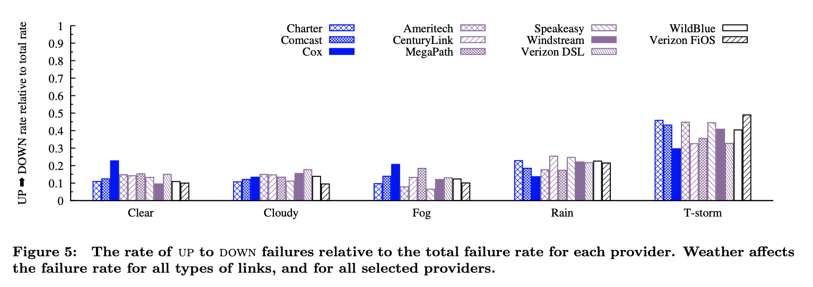

*The impacts of rain and thunderstorms are particularly clear on service outages for ISPs[28].*

With optimistic hopes of 5G around the corner, a development that will rely on the use of high frequency bands to communicate signals that will wither quickly over short spatial envelopes, strenuous weather conditions like this will remain a difficult challenge to overcome when they are present. The need for a rich network of 5G nodes is already present due to the natural attenuation of high frequency communications, but with the added presence of fog and rain, solutions for 5G networks in areas at risk for weather-related climate events may need more advanced technical solutions to realize this goal.

**Infrastructure and Stakeholders**

Federal, state, city agencies and private entities maintain collective responsibility for telecommunications systems, but without a unified and coordinated allocation of responsibility, which can become especially clouded during emergency events. Because none is charged with the responsibility of ensuring service during emergencies, interoperability has emerged as a common pattern in nearly every step of the development and operations process of this infrastructure (and surfaced more apparently during times of disaster).

**Deployment**

The deployment of cable across the United States was realized by action of private companies, along high-service areas where demand boomed. While the internet backbone was initially a public project at the center of Arpanet, it transitioned into a privatized interest in 1994 under the Clinton administration. Long-distance internet traffic was at stake, and private firms absorbed the capital intensity of installing this infrastructure while gaining control of critical pieces of the backbone.

Cable was often installed near other public infrastructure like power lines and roads, but its ultimate plan at the urban scale was not a coordinated effort between companies (beyond cooperation in dividing territories to maintain market dominance in respective regions). Telecommunications companies keep information about the specific locations of these cables private, making assembling a 30,000 foot view of internet cable a thorny process.

Cable is not uniformly deployed, and the cost of installation varies over different geographic regions, as the cost of burying in different terrains and laying stake to property varies. Dropping fiber optic cable is an extremely expensive undertaking, at tens of thousands of dollars per mile installed, based on 2017 estimates from the Department of Transportation[29], and only a handful of companies dominate in ownership of the internet backbone in the US. As mentioned before, microtrenching does offer less expensive alternatives for the shallow burying of cable, but with few contractors offering microtrenches as it is still rising as an installation method, pursuing this method may still be inaccessible or priced expensively in some areas.

Because of the network effects of telecommunications, the more people an ISP can service in an area, the cheaper it is to deploy infrastructure. This leads to population-dense urban centers to be the target markets for companies in this sector seeking to maximize profit. More generally, incenting wirelines carriers to invest in fiber is difficult, as they are reluctant to do so, with capital expenses ranging between 14-18% of revenue, barring the debt and interest accumulated in the process[30]. Without payback guaranteed over short periods of time, other incentives like new footprints, required rebuilding after damages, and subsidies like Universal Service funds are used to incentivize investment in fiber deployment. Based on a 2017 Deloitte report, in deployment, regulatory barriers require ISPs investing in wired networks to obtain and maintain permits, prevent carriers from operating a single IP network, and can restrict the “type of services offered.” The same report suggests policy solutions that broaden the potential profit models of companies, allow for the voluntary sharing of deep fiber and expand a company’s ability to innovate may help. Additionally, the report suggests that dispersing universal service subsidies could encourage the faster deployment of deep fiber.

A separate 2018 analysis on 5G by Accenture reports that there are also significant regulatory burdens imposed by the National Historic Preservation Act and the National Environmental Policy Act (NHPA/NEPA) that account for 29% of deployment costs for 5G small cell roll-outs[31]. The FCC, in September 2018, lifted several regulatory hurdles to allow for the proliferation of small wireless and wired facilities. In its declaratory ruling[32], it acknowledged that local and state fees could still stand in opposition to these new incentives to invest. Other local and state tools like decisions on rights of way to public infrastructure, undergrounding requirements (local requirements on how deep cable is buried), zoning requirements, and minimum spacing requirements could also stand in the way of private sector 5G deployment but these functions are indistinguishable from their roles as regulators[33]. Rights of way can bear a significant burden on the cost of construction based on one FCC report, which suggests these regulatory hurdles may offer some challenges to private entities seeking to reinvest in their networks[34].

The FCC has also softened unbundling requirements imposed by the Telecommunications Act of 1996 by 2005, restricting the kinds of UNEs that ILECs were initially required to unbundle and share. This liberated fiber to the home (FTTH) from unbundling requirements, and line sharing as well.

In this process, deployment requires support from local governments, capital to fund the construction and permits to build a network, and a path to profitability for private entities looking to recoup their investments quickly. Though FCC action is consistent with motives to increase fiber deployment across the US, 5G and fiber are still slow to cover the nation, the incentive to lay fiber has not resulted in an upgraded infrastructure.

**Maintenance, Outages and Repair**

Reinstalling cable en masse has historically only happened during a switch from early single steel and iron wires to copper and fiber as methods of making cable dramatically improved in the early 20th century. Something like this would unlikely happen again because of the privatized model of ownership, and a lack of incentive to upgrade cable at scale. Based on the Fiber Optic Associations guidelines, most fiber networks can be designed to not need repairs or periodic maintenance[35]. Because maintenance requires often leaving an entire link offline, some service providers may use alternative links to handle traffic in the interim, if repairs are necessary. If there are breakages along a fiber cable, they can be detected from a distance. Because fiber can be wrapped with conductive metals, often helical steel, testing the resistance of the metal to determine how far a signal might travel along it can be performed at a distance from the site of the break itself.

Networks like these often require the most maintenance and repair during times of natural disasters. The stages of network failure in a storm begin with the loss of power, as cell towers, routers and modems will not work if they are not powered. Physical damage to wired infrastructure, perhaps caused by flooding in a building that drowns cable switches or the fall of towers and other network elements results in a much more enduring and costly outage. Hurricane-force winds and seismic activity can bring entire cell towers down, and disrupt fiber networks, both of which are expensive to reinstall and require a construction crew which often cannot mobilize in times of disasters. Excavating cable is also difficult, because pinpointing a specific location of damage is nearly impossible and requires some trial and error. Wireless links may have their signals obscured by humidity and rain, and transmitters might be knocked off their alignments and require repositioning (though these kinds of issues are much more affordable to fix, and significantly more temporary). If networks are online, they become a chokepoint[36], because of an influx of network activity resulting from the coordination of emergency services, relief, and recovery. This oversaturation of a network beyond its capacity can result in the dropping of packets, and the loss of information.

Several networks have historically been affected by severe weather events. Hurricane Katrina left 60% of networks down, 3 weeks after the hurricane had passed[37]. Hurricane Sandy impacted Verizon, Cablevision, Time Warner Cable Inc., and AT&T resulting in broad scale network outages. Even the “telecom hotel” where Google NY’s office was housed experienced outages during the hurricane for multiple days[38]. One successful adaptation strategy in Miami, Florida was with a Skybox data center, which managed to stay online during the entirety of Hurricane Irma. Equipped with generators, thick walls to block storm surge and plans for cooling, powering and protecting machines in the case of storms[39]. Historically, the federal government has supplied funding directed towards rebuilding communications infrastructure during these natural disasters, though the degree of this aid has varied radically depending on the severity of the situation.

The Federal Government’s role has been to accelerate the process of the repair of this infrastructure, as it is crucial in search and relief efforts, and eventually, the healthy functioning of affected areas. As early as the Communications Act of 1934, 47 U.S.C. §§ 151-615b, the government aimed to reduce burdens for temporary solutions in the event of natural disaster, or terror attack –

*“This legislation provides the authority to grant special temporary access an expedited basis to operate radio frequency devices. It could serve as the basis for obtaining a temporary permit to establish a radio station to be run by a federal agency and broadcast public service announcements during the immediate aftermath of an emergency or major disaster. Likewise, 47 U.S.C. § 606 (2002) provides the authority for the NCS to engage in emergency response, restoration, and recovery of the telecommunications infrastructure.”[40]*

In a significantly more recent Notice of Inquiry issued by the FCC, some clear attention is dedicated to the action required of the agency for disaster affected areas.[41]

***“****The Commission normally measures broadband deployment progress under the assumption that existing infrastructure will be built upon and expanded. However, natural disasters can dramatically reduce levels of broadband deployment in affected areas. For example, the government of Puerto Rico estimates that in 2017 Hurricanes Irma and Maria caused approximately $1.5 billion of damage to Puerto Rico’s communications network. We seek comment on how to address natural disasters in reporting on the progress of deploying broadband. How should our inquiry take into account efforts by the Commission and other parties to restore networks in the wake of a natural disaster? Are there other particular factors we should take into consideration in natural disaster-affected areas when evaluating deployment progress, such as the recognition that funding will largely support operations rather than deployment soon after the disaster? How should we take into consideration such things as storm hardening when conducting our inquiry?”*

While public response to this inquiry has not materialized clear results, it does indicate that a more clear pathway for Federal response under the Commission may be of interest. Some responses acknowledge a need for the commission to incentivize the development of more broadband, to help better prepare the baseline of areas that in the future, would be left with an entirely broken infrastructure if no preventative investment happens in advance[42]. Currently, the FCC suggests voluntary reporting of outages during storms to supplant its awareness of the severity of damage.

**Resilient Cities**

Some resilient communities discuss the use of mesh networks to maintaining communications for short ranges in lieu of their usual network during outages like these. Some commercial products are already available to meet these needs, but as one article points out, “the technical complexities of building a network are a lot easier to overcome than the political complexities of building community, political agency, and governance.[43]” Mesh networks only offer extremely short ranges and are not a viable alternative during moments of disaster to robust wired communications. Other efforts in services like Cellular On Wheels (COW) were used in the aftermath of Hurricane Katrina, in areas most devastated by the storm to coordinate search and rescue recovery.

Because every city and local stakeholder structure varies, especially with regards to its recovery processes, the following section will include case studies focused on New York and Miami.

**New York**

New York City is a critical site of landing stations, data centers, IXPs, and a dense web of its own local networks. It is historically the oldest city to have entered the early internet network that also overlaps with major clusters of modern-day infrastructure. New York is also at a marked risk of flooding, and has been built on landfills to extend its geographic area, which leave it particularly vulnerable to climate change’s impacts as early as 2020.

On a broad scale, the authority to regulate telecommunications infrastructure in New York City is divided by the Federal Communications Commission and the New York State Public Service Commission (PSC). The FCC has authority over wireless, long-distance phone and Internet services while the PSC maintains authority on regulating traditional local landline services which are less commonly used, today. Both the FCC, the PSC and NYC share authority on regulating cable TV service. Other government agencies also are folded into the management of these networks, like the Department of Information Technology and Telecommunications (DoITT). The DoITT largely administers communications services for local agencies, overseeing franchises that are implicated when companies file for access to public rights of way, and for managing fees and compensation in the process. The NYC Department of Transportation permits construction after permits are granted by the DoITT, and the Department of Buildings determines standards for the placement of equipment, power sources, and other critical infrastructural elements at telecommunications facilities. With shifts in technology (like VoIP), the power vested in each authority has also flowed and shifted, resulting in a web of overlapping jurisdictions which is not unique to New York.

In response to Superstorm Sandy the NY Department of Information Technology and Telecommunications also launched the Telecommunications Planning and Resiliency Office (TPRO). Since its establishment, the TPRO has not spurred much public action but has produced an extremely comprehensive report on strategies to be better prepared in future major climate events. The report included several initiatives to establish research and task forces, but has not led to publicly visible investment as a response to it.

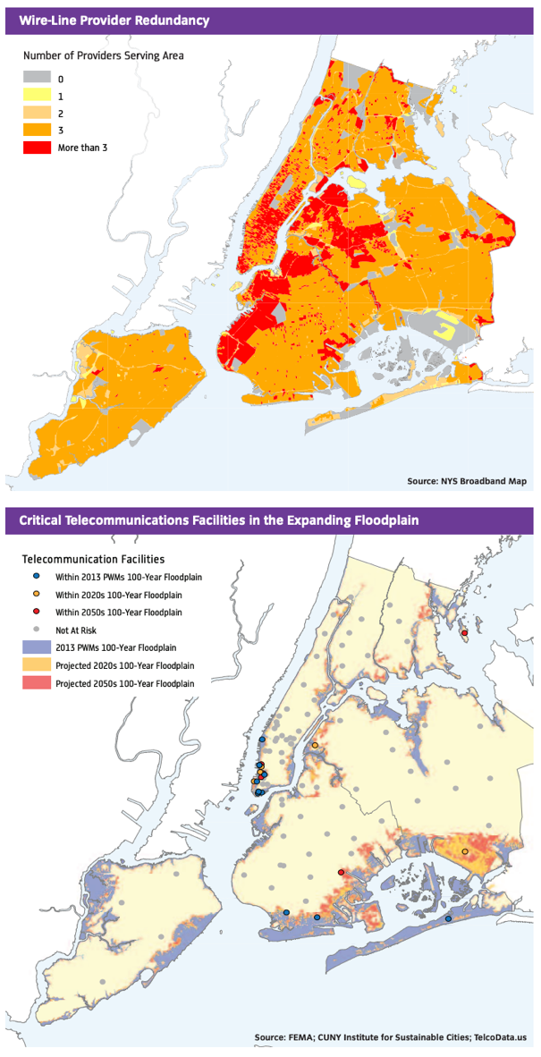The report also identified that 13% of critical telecommunications facilities lie in FEMA’s projected 100-year floodmaps, and that even by 2020, storm surge will already pose a significant “major risk” to these facilities[44]. With New York’s density and high-rises, repairing copper cable, restoring power and replacing equipment that was damaged by flooding left full-service restoration as long as 100 days in several parts of the city (see map to the left).

34,600 low-rise buildings experienced 3 feet of flooding, which crosses the threshold of the amount needed to damage telecommunications equipment. For 1,400 high-rise buildings, the barrier to damage is significantly lower, at 1 foot of flooding required to reach the basement and damage centralized areas that are responsible for keeping entire buildings connected[45]. The composition of a city – in terms of its density, age, and zoning requirements have an enormous impact on what the repair process looks like in the event of severe flooding. For New York, the density of this urban center had a clear negative impact on the time it took to coordinate, prioritize, and manually repair each broken endpoint. It is unlikely that New York will be given an opportunity to develop large swatch of its dense urban core in the near or distant future, so finding ways to install higher quality network infrastructure that is more resilient to flooding may be the best adaptation for the city’s private sector.

Among the repairs were notably those of Verizon, which saw several damages to its copper cables. Though the long-term benefits of upgrading the copper infrastructure are clear now, at the time, fixing these services left several landline users in the area without telephone services during a period of continuing disaster recovery without alternative options. During its recovery efforts, Verizon took the posture of “hardening” its repair sites by installing raised generators, raised switchgear, fiber deployment and new copper with stronger sheaths, and recommends pumps to mitigate flooding when it does occur[46]. Implementing better systems while gutting the older copper wire has allowed offices on this improved infrastructure to get back online in under 24 hours during other storms, where offices that fall behind took up to 11 days to recover. To aid during this downtime, COWs were also introduced to specifically poorly connected areas.

Despite the clear need for investment into resiliency across New York City, the report includes a note of caution, stating that while the recommendations are firmly in place and known, that funding is still yet lacking to implement solutions.

Other mitigation strategies on a city level are also taking place. New York launched the “RISE:NYC Resiliency Innovations for a Stronger Economy” competition 2014 in response to Superstorm Sandy, including three winning projects focusing on the development of resilient telecommunications networks[47]. While it is hard to track the outcomes of those three projects, this has resulted in the stewardship of digital innovations to prepare NY for the next time a storm does debilitate its wired infrastructure.

**Miami, Florida**

Miami is a city with an extremely disparate wealth gap that is visible, especially around Miami-Dade county and Broward County[48]. Apart from these social structures, Miami is also a resilient city embattled against the consistent threat of natural disasters that challenge its infrastructure. With most of Miami elevated to the same level as the sea, it also must confront the physical realities of climate change immediately to prepare itself for the IPCC’s projections. Though it was not initially at the center of the Internet like the New England area was, Miami has also become a central site of several critical IXPs and faces obvious threats from climate change given its proximity to the coast.

Like New York, Miami is also entrenched in a complex regulatory landscape for telecommunications. While the FCC maintains Federal oversight on a wide array of service requirements, spectrum licensing and service limitations, Florida maintains a Public Service Commission (PSC) charged with oversight of telecommunications, oil and gas utilities and water system management. Under this authority, the PSC ensures that “incumbent local exchange carriers meet their obligation to provide unbundled access, interconnection, and resale to competitive local exchange companies in a nondiscriminatory manner.[49]” Other than local competition arbitration and licensing, it also oversees the implementation of the Lifeline program in Florida with the goal of offering sufficient services to the deaf, hard-of-hearing or speech-impaired. On a county level, right of way licenses are issued and permitting, and construction authorities are also housed on county-level.

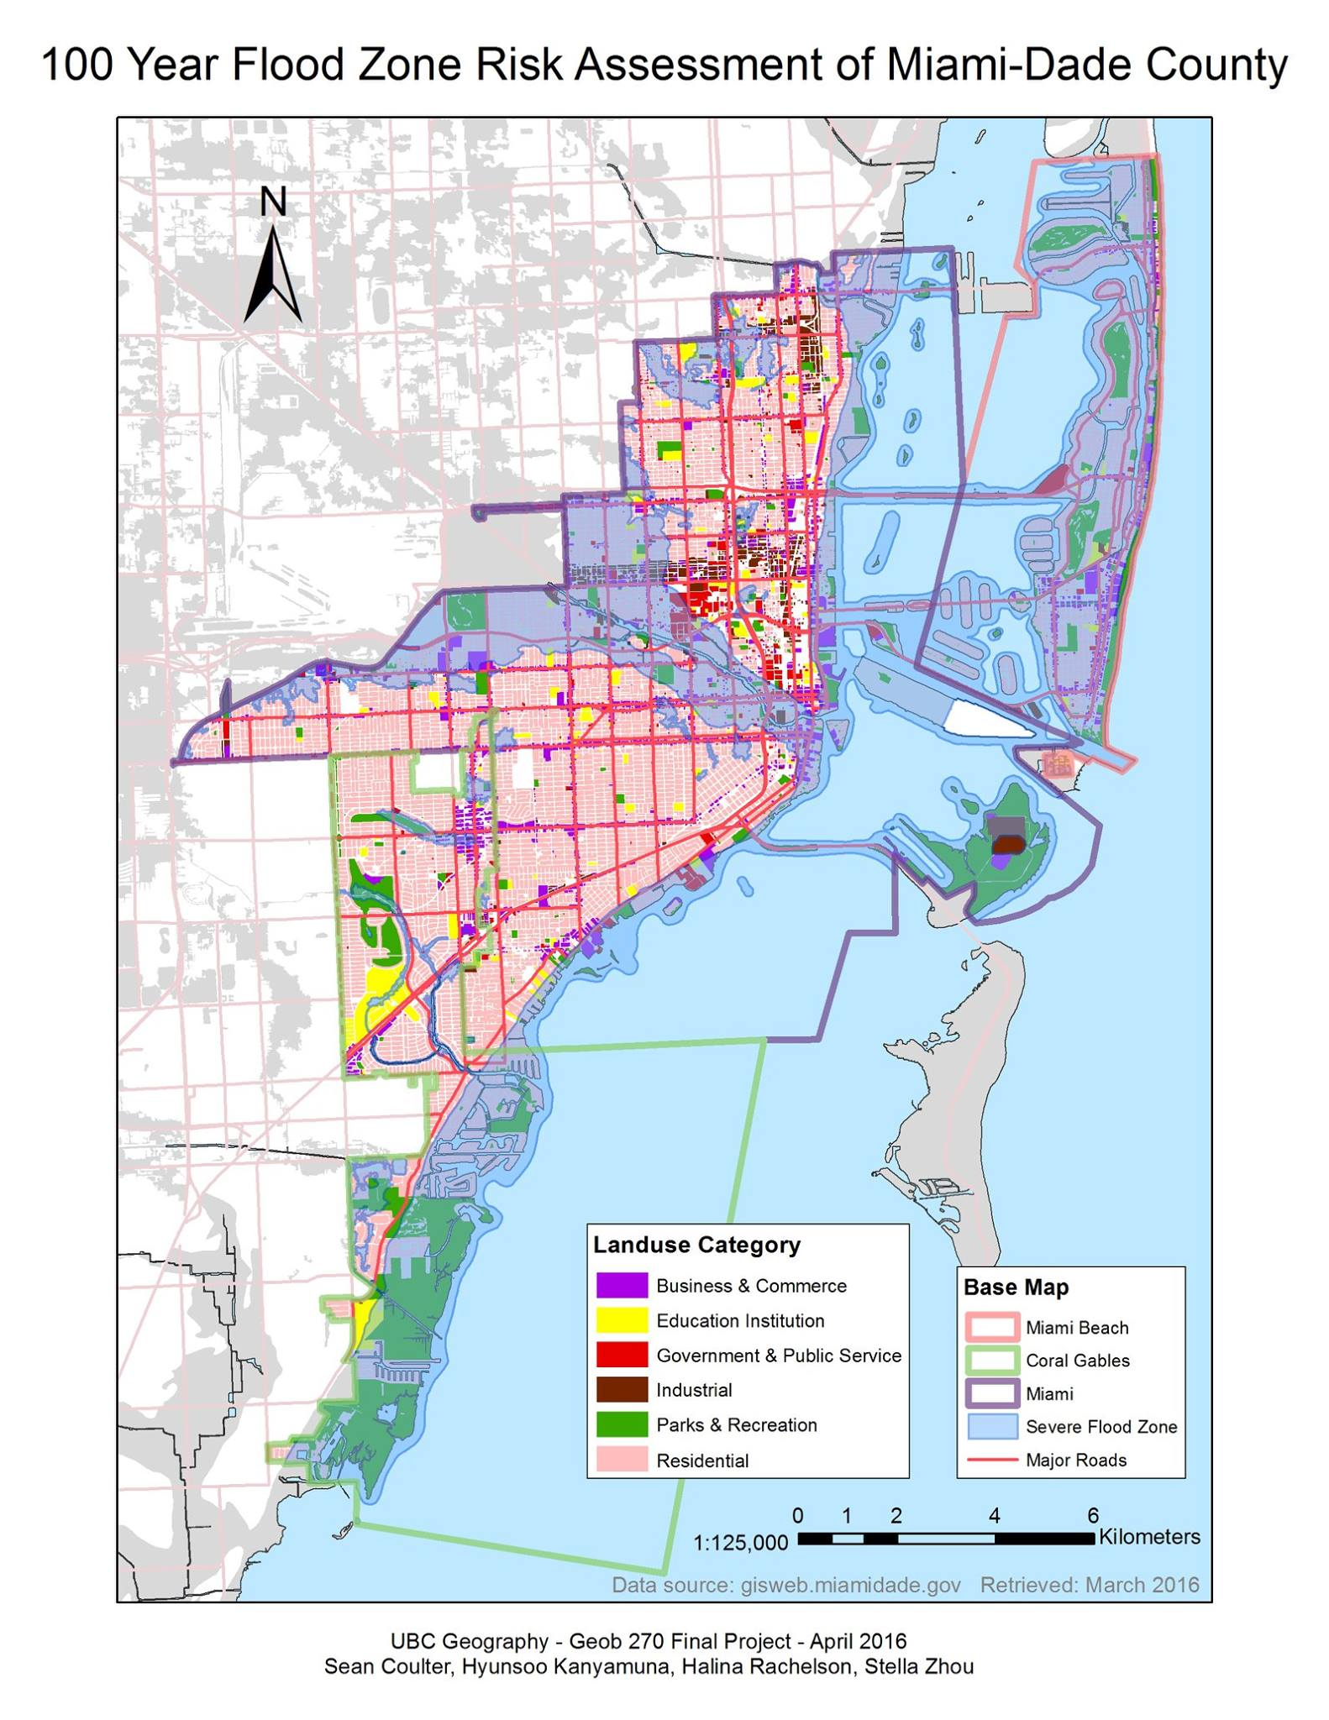

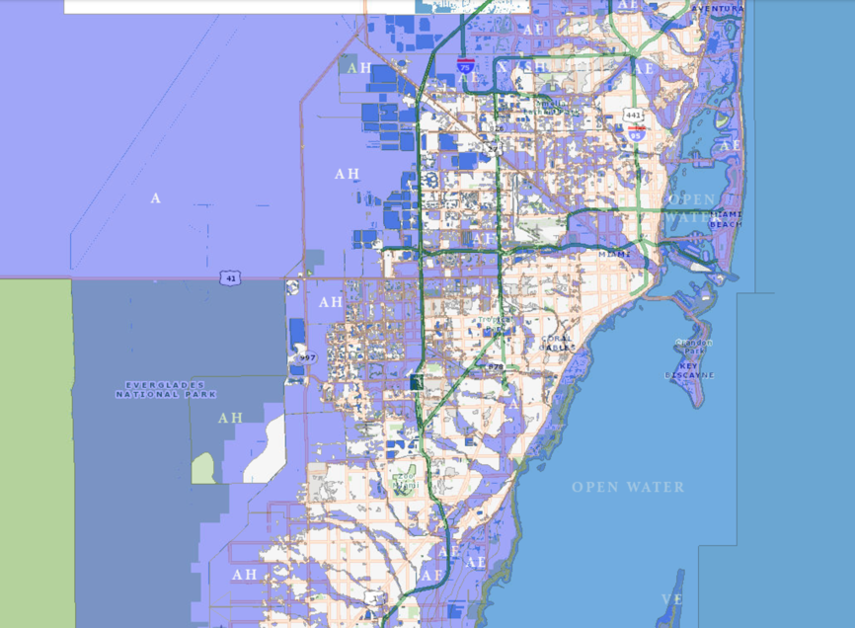

*Shaded blue areas indicate risk in 100-year projections* on the left[50], while the map on the right indicates that government and public service centers, along with business centers at the urban core also remain at risk of severe flooding[51]. Many residential developments along the floodplain also face dire risk within the next 100 years.

Much of Miami will be underwater according to FEMA’s 100-year floodplain projections. 5 of 6 TV transmitter sites, and 12 of 22 of Miami-Dade’s radio transmitter sites will be under two feet of water which has an 80% likelihood of being realized by 2030, and a 100% likelihood by 2040[52]. Beachfront properties are already starting to experience this flood risk as well, and entire developments like Miami Beach are expected to be submerged. Most of Miami is residential, and low-rise but in coastal areas and along the dense urban core (64% are in Downtown Miami[53]), several new high-rises have been developed in the last two decades. Following Hurricane Andrew, the high-rise “boom” brought more than 42,000 condos to Miami Beach, Coconut Grove, Brickell and Sunny Isles, neighborhoods firmly positioned along the coast[54]. These coastal areas are in part supported by landfill extensions that will be underwater within the next two decades.

Because of the aftermath of Hurricane Andrew, Miami-Dade building code was updated with stronger requirements – the first 30 feet of high rises must have high impact windows, to protect people from the range of motion that travelling debris has in high winds. Stairwells are reinforced with shear concrete, functioning as spines to high rises. Buildings must sustain winds of 175 mph (Hurricane Irma reached record speeds of 177 mph[55]). Despite these protections, even recent Tropical Storm Emily (2017) caused flooding, and assistant fire chief and emergency manager for the City of Miami, Pete Gomez, even stated “we can’t force you to evacuate, but there’s a good possibility that if you dial 911, no one is going to be able to help you.” Though infrastructure might be more robust, flooding still remains a risk that requires careful maintenance of the city’s telecommunications infrastructure.

The sweeping impacts of flood risk on infrastructure have potentially broader consequences. One empirical study was able to validate that appreciation in low-elevation areas in Miami at greater risk of severe flooding over a long time horizon is lower than it is in high elevation areas[56]. With climate gentrification in sight, and an imminent risk that remains unaddressed is for Miami’s underserved and underinvested communities. Overtown, for example, which has no high-rise developments and has not been the site of resilient investment, suffers a risk of 10 inches of sea level rise by 2030[57], and projections of 50,000 residents displaced[58]. Without investment in these communities to maintain adequate housing at an affordable cost, it seems unlikely that telecommunications investment will occur here to make systems more robust against severe weather events without public sector intervention.

**Hurricane Irma**

Miami has most recently been affected by Hurricane Irma, though it has been the site of numerous damages related to a dense history of tropical storms and hurricanes. During its 14-day journey across the Southeastern coast and the Caribbean, Irma was reported to make seven landfalls and reached Category 5 status. Storm surges ranged between 5 and 8 feet in parts of Florida, and Miami was flooded not only by heavy rains, but also storm water and seawater that was carried through the city’s entirely saturated drainage system. Based on soil analyses after the storm, it was reported that surge was only responsible for “flooding a block or two from the bay,” but that the lack of sufficient drainage had heavy impacts inland[59].

Irma’s impacts on telecommunications were palpable, and enduring. Major telecommunications providers like AT&T, Comcast, Atlantic Broadband and Frontier faced outages during the Irma’s tenure. During the hurricane an estimated 7 million cable and wirelines subscribers lost their connections[60]. 24% of cell sites were out of service in Florida, and as many as 50% in Southeast Florida. While some metrics are present for measuring outages, the richest source of this data remains undisclosed. According to FCC reporting, most call centers in USXI remained afloat, though hurricanes, especially in rapid succession of each other left Florida offline for over a week, and specific areas offline for much longer[61].

Comcast declined to share how many of their subscribers experienced outages during Irma. “Comcast, the biggest cable and broadband provider in the US, declined to say how many of its customers have lost service. Comcast said it made 150,000 of its Wi-Fi hotspots in Florida, Georgia, and South Carolina available to anyone during the storm, even non-Comcast subscribers.[62]”

Other service providers like Frontier reported that its FiOS services, which are resilient to water and flood conditions, also experienced outages of around 50% of their Florida subscribers[63]. In this case, outages were not because of a damage to the physical network but because of the lack of power to keep FiOS online. Back-up power generators were used in some situations to keep internet services running despite the outages, but were not sufficient to keep all subscribers in the loop.

AT&T also suffered from extensive outages, possibly the worst of all ISPs in the area[64]. Though it was able to swiftly restore its U-verse services, several cell sites and older network elements suffered and needed significant repair. Hurricane Irma was associated with angry subscribers taking to Twitter, filing complaints against Comcast and AT&T for their lack of transparency and accountability in swift recovery[65].

Finally, the Florida Power and Light company reported major damage to its own infrastructure –

“*We are working on cable lines and nodes that were essentially fried by electrical fires over FPL lines. It’s a complex and difficult restoration process in this area,” she said via email. “In some cases we also have fiber cuts that have been caused by lines coming down, debris removal crews inadvertently cutting our lines, damaged poles, etc.*”[66]

After a coordinated effort by the National Guard, charities, local and private stakeholders, Southeast Florida was largely restored after these outages. But in this restoration process, each private telecommunications company worked to swiftly restore its services, in the process, did not install new resilient services unless components of their networks were entirely damaged and needed to be upgraded.

**Planning Ahead**

Miami has already spent $200 million raising the height of its streets, and building strategic sea walls around its city center and coastal shores[67]. But sea walls do not drain water, and simply move it around, potentially compounding problems in other areas. As a result, the need for a coordinated effort to mitigate and adapt is needed at an urban scale. Miami also announced a $100 million plan to protect against flooding, in a program called Rising Above Risk, organized by the City of Miami Beach[68]. The plan discusses the installation of new water mains, storm water drainage pumps, and upgraded sewer connections. While these can reduce the effect of flooding and work to drain Miami in areas that are most severely impacted, even this program still remains deadlocked between several stakeholders. Seawalls, for example, are largely maintained by private companies along the coast with only 3 miles that are publicly owned[69]. Because core elements of infrastructure that have the power to redirect water in potentially harmful ways across the city are not managed in a coordinate effort, broader risks are difficult to plan for. Flood modeling, for instance depends on inputs from these infrastructure, and will ultimately inform how new infrastructure (transportation, utilities, communications) should be designed and implemented.

A City of Miami meeting on Sea Level Rise also mentioned the division of Miami into 6 sectors and tackling those separately, with varied funding and priorities depending on the sector[70]. A separate report issued by the Urban Land Institute[71] sought to delineate specific percentages to each category of prioritization. 9% of priority was assigned to the shocks expected by cybersecurity and communications infrastructure failure, the same amount dedicated to transportation. Beyond this, there are no specific policy or private sector recommendations for encouraging the construction of a more resilient network that can stand against future severe weather events.

Generally, Miami’s strategy seems to largely rest on the use of zoning for long-term improvements in urban resilience and the deployment of smaller-scale mitigation strategies to handle drainage. On a separate axes, the role of public sector may change in the following decade with projections of buying low-elevation land with goals of turning these sites into blue and green environmental remediation facilities that can drain water during storms. Where telecommunications infrastructure fits into the picture is ambiguous, but it has been raised as a priority and will be necessary to implement the other priorities raised.

**Conclusion**

Telecommunications pipelines are complex systems – built over time with compounding complexities from keeping new technology backwards compatible with the old, managed by stakeholders with rich but private data, and regulated by authorities spanning a local to Federal reach, these networks serve a critical lifeline to everyone in the US. With the looming threats of climate change at dense centers of infrastructure along this network, it is clear that without action, our networks will not be resilient to storms and chronic weather conditions as soon as by 2030. It is also clear that strategies to mitigate and adapt cannot be universally applied. Cities vary so much, from their topographic variation to their varied risks to their varied urban construction, action will need to vary subject to different areas.

On a Federal level, it is clear that promoting the development of fiber and keeping America connected will matter as a preventative strategy, though those who are not served in these situations may suffer from both poor climate conditions and a lack of connectivity. On a state level, the coordination of competition to incite the development of fiber at a larger-than-local scale may aid in upgrading several cities out of their old copper, or previous lack of sufficient connection. On a local level, community developers will also continue playing a key role, working towards building alternative resilient mesh networks and local strategies to preserve their agency. Coordinated efforts between urban planners, zoning committees, utilities coordinators and telecommunications companies can lead to more unified development at lower costs, and can lay the groundwork for robust infrastructure that is built to be resilient to the challenges that lie ahead.

**Related Papers**

<https://www.nationalgeographic.com/science/2018/07/news-internet-underwater-sea-level-rise/>

<https://news.nationalgeographic.com/2017/07/sea-level-rise-flood-global-warming-science/>

<http://cryptome.org/eyeball/cablew/cablew-eyeball.htm>

West Coast Infrastructure Mapped

<http://pages.cs.wisc.edu/~pb/tubes_final.pdf>

C40 – Sustainable Cities Coalition

<https://www.c40.org/events/the-sustainability-summit>

FCC 2017 Hurricane Season Impact Analysis

<https://docs.fcc.gov/public/attachments/DOC-353805A1.pdf>

<http://pages.cs.wisc.edu/~pb/tubes_final.pdf>

<http://www.arrl.org/files/file/Technology/pdf/QST_Aug_2001_p62-64.pdf>

Ramakrishnan Durairajan, Paul Barford, Joel Sommers, and Walter Willinger. 2015. InterTubes: A Study of the US Long-haul Fiber-optic Infrastructure. In ACM SIGCOMM

<https://coast.noaa.gov/slr/#/layer/vul-soc/0/-10655107.718826042/4649592.712140727/4/satellite/48/0.8/2050/interHigh/midAccretion>

<https://www.multichannel.com/news/fcc-headquarters-closed-for-water-damage>

Oddly enough, the government does not have strict requirements for the resilience of p-clouds and other secure databases that are managed by third-party entities as a national policy.

1998 – Miami Fiber Plan (page 20 includes a proposed map of fiber lines)

<http://miamidadetpo.org/library/studies/fiberoptic-communications-concept-plan-forintelligent-transportation-infrastructure-1998-06.pdf>

1. M. Allen, O. P. Dube, W. Solecki, F. Aragón–Durand, W. Cramer, S. Humphreys, M. Kainuma, J. Kala, N. Mahowald, Y. Mulugetta, R. Perez, M. Wairiu, K. Zickfeld, 2018, Framing and Context. In: Global warming of 1.5°C. An IPCC Special Report on the impacts of global warming of 1.5°C above pre-industrial levels and related global greenhouse gas emission pathways, in the context of strengthening the global response to the threat of climate change, sustainable development, and efforts to eradicate poverty [V. Masson-Delmotte, P. Zhai, H. O. Pörtner, D. Roberts, J. Skea, P.R. Shukla, A. Pirani, W. Moufouma-Okia, C. Péan, R. Pidcock, S. Connors, J. B. R. Matthews, Y. Chen, X. Zhou, M. I. Gomis, E. Lonnoy, T. Maycock, M. Tignor, T. Waterfield (eds.)]. In Press. Accessed 1 Dec 2018.

   <http://report.ipcc.ch/sr15/pdf/sr15_ts.pdf>
2. Jonathan Gregory. [n. d.]. Climate Change 2013: The Physical Science Basis: Projections of sea level rise. https://www.ipcc.ch/pdf/unfccc/ cop19/3_gregory13sbsta.pdf.
3. ["Global Internet Exchange Points / BGP Peering Points / IXP"](http://www.bgp4.as/internet-exchanges). *BGP: The Border Gateway Protocol Advanced Internet Routing Resources*. p4. 20 October 2011.
4. Internet Exchange Map, Accessed 1 Dec 2018.

   [*internetexchangemap.com*](http://internetexchangemap.com/)
5. Datanyze CDN Market Share Report, Datanyze. Accessed December 2018.

   <https://www.datanyze.com/market-share/cdn/amazon-cloudfront-market-share>
6. AWS Webcast: Whole Site Delivery with AWS CloudFront (12:56), Amazon WebServices. 20 May 2013. Accessed 18 Dec 2018.

   <https://www.youtube.com/watch?v=nBsZ2UkxYbY>
7. O. Hoegh-Guldberg, D. Jacob, M. Taylor, M. Bindi, S. Brown, I. Camilloni, A. Diedhiou, R. Djalante, K. Ebi, F. Engelbrecht, J. Guiot, Y. Hijioka, S. Mehrotra, A. Payne, S. I. Seneviratne, A. Thomas, R. Warren, G. Zhou, 2018, **Impacts of 1.5°C global warming on natural and human systems. In: Global warming of 1.5°C. An IPCC Special Report on the impacts of global warming of 1.5°C above pre-industrial levels and related global greenhouse gas emission pathways, in the context of strengthening the global response to the threat of climate change, sustainable development, and efforts to eradicate poverty** [V. Masson-Delmotte, P. Zhai, H. O. Pörtner, D. Roberts, J. Skea, P.R. Shukla, A. Pirani, W. Moufouma-Okia, C. Péan, R. Pidcock, S. Connors, J. B. R. Matthews, Y. Chen, X. Zhou, M. I. Gomis, E. Lonnoy, T. Maycock, M. Tignor, T. Waterfield (eds.)]. In Press.

   Accessed 17 Dec 2018.

   <http://report.ipcc.ch/sr15/pdf/sr15_ts.pdf>
8. A.1.2 Warming greater than the global annual average is being experienced in many land regions and seasons, including two to three times higher in the Arctic. Warming is generally higher over land than over the ocean. (high confidence) {1.2.1, 1.2.2, Figure 1.1, Figure 1.3, 3.3.1, 3.3.2},
9. USGCRP, 2018: *Impacts, Risks, and Adaptation in the United States: Fourth National Climate Assessment, Volume II* [Reidmiller, D.R., C.W. Avery, D.R. Easterling, K.E. Kunkel, K.L.M. Lewis, T.K. Maycock, and B.C. Stewart (eds.)]. U.S. Global Change Research Program, Washington, DC, USA, 1515 pp. doi: 10.7930/NCA4.2018.
10. McNeill, R., D.J. Nelson, and D. Wilson, 2014: Water’s Edge: The Crisis of Rising Sea Levels. Reuters Investigates. Thomson Reuters. [https://www.reuters.com/investigates/special-report/ waters-edge-the-crisis-of-rising-sea-levels/](https://www.reuters.com/investigates/special-report/%20waters-edge-the-crisis-of-rising-sea-levels/)
11. Vogel, J., K.M. Carney, J.B. Smith, C. Herrick, M. Stults, M. O’Grady, A.S. Juliana, H. Hosterman, and L. Giangola, 2016: Climate Adaptation—The State of Practice in U.S. Communities. Kresge Foundation, Detroit. [http://kresge.org/sites/default/files/ library/climate-adaptation-the-state-of-practicein-us-communities-full-report.pdf](http://kresge.org/sites/default/files/%20library/climate-adaptation-the-state-of-practicein-us-communities-full-report.pdf)
12. *Subtext on the page suggests that the data is “powered by McKinsey and Company” though the source data and processing to determine this ranking is not clear.*

    Internet Access Ratings, US News, Accessed 17 Dec 2018.

    <https://www.usnews.com/news/best-states/rankings/infrastructure/internet-access>
13. 10 States Most at Risk of Flooding. US News. Accessed 17 Dec 2018. https://www.usnews.com/news/slideshows/10-states-most-at-risk-of-flooding
14. Torres, D. and M. Maletjane, 2015: Information and Communication Technologies for Climate Change Adaptation in Cities. International Telecommunication Union (ITU), Focus Group on Smart Sustainable Cities—Working Group 2, 33 pp. [https://www.itu.int/en/ITU-T/focusgroups/ssc/ Documents/website/web-fg-ssc-0107-r7-ICTs-forclimate-change-adaptation.docx](https://www.itu.int/en/ITU-T/focusgroups/ssc/%20Documents/website/web-fg-ssc-0107-r7-ICTs-forclimate-change-adaptation.docx)
15. The Global Risks Report 2018: 13th Edition, World Economic Forum. 17 Jan 2018. Accessed 18 Dec 2018.

    <http://www3.weforum.org/docs/WEF_GRR18_Report.pdf>
16. The Global Risks Report 2018: 13th Edition, World Economic Forum. 17 Jan 2018. Accessed 18 Dec 2018.

    <http://www3.weforum.org/docs/WEF_GRR18_Report.pdf>
17. A historical archive from the New York Times, published on July 24, 1858 situates this story in context.

    THE ATLANTIC TELEGRAPH EXPEDITION. The New York Times, 24 Jul 1858.

    <https://timesmachine.nytimes.com/timesmachine/1858/07/24/78857687.html?action=click&contentCollection=Archives&module=LedeAsset&region=ArchiveBody&pgtype=article&pageNumber=1>
18. First transatlantic cable connects the United States to England, JP Morgan, Accessed 18 Dec 2018, <https://www.jpmorgan.com/country/US/en/jpmorgan/about/history/month/aug>
19. Reese, Nick. BroadbandNow DSL Analysis, Accessed 17 Dec 2018. <https://broadbandnow.com/DSL>
20. *One report states that between 2012-2013, DSL has been shrinking by only 0.3 percent each quarter.*

    Protalinski, Emily. Over 70% of US households now have broadband Internet access, with cable powering over 50% of the market.

    The Next Web, 9 Dec 2013. Accessed 16 Dec 2018.

    <https://thenextweb.com/insider/2013/12/09/70-us-households-now-broadband-internet-access-cable-powering-50-market/>
21. Fiber Optic Installation by Microtrenching, The Fiber Optic Association, <http://www.thefoa.org/tech/ref/install/Microtrenching/index.html>
22. The Impact of Water on Fibre Optic Cable. 2014. Accessed 17 Dec 2018.

    <http://www.cabling.datwyler.com/supportdownloads/ict-networks.html>
23. Greg's Cable Map, Accessed 18 Dec 2018. <https://www.cablemap.info/>
24. Durairajan, Ramakrishnan & Barford, Carol & Barford, Paul. (2018). Lights Out: Climate Change Risk to Internet Infrastructure. 9-15. 10.1145/3232755.3232775.
25. Messer, Hagit & Zinevich, Artem & Alpert, Pinhas. (2006). Environmental monitoring by wireless. Science (New York, N.Y.). 312. 713. 10.1126/science.1120034.
26. Aart Overeem, Hidde Leijnse, Remko Uijlenhoet. Rainfall maps from cellular communication networks. Proceedings of the National Academy of Sciences. Feb 2013, 110 (8) 2741-2745; DOI:10.1073/pnas.1217961110
27. Aaron Schulman , Neil Spring, Pingin' in the rain, Proceedings of the 2011 ACM SIGCOMM conference on Internet measurement conference, November 02-04, 2011, Berlin, Germany. [10.1145/2068816.2068819](http://doi.acm.org/10.1145/2068816.2068819)
28. Aaron Schulman , Neil Spring, Pingin' in the rain, Proceedings of the 2011 ACM SIGCOMM conference on Internet measurement conference, November 02-04, 2011, Berlin, Germany. [10.1145/2068816.2068819](http://doi.acm.org/10.1145/2068816.2068819)
29. RUC By Unit Cost Element Unadjusted, ITS Costs, https://www.itscosts.its.dot.gov/its/benecost.nsf/DisplayRUCByUnitCostElementUnadjusted?ReadForm&UnitCostElement=Fiber+Optic+Cable+Installation+&Subsystem=Roadside+Telecommunications+
30. *It is unclear over what period of time and what service area was used to inform this estimation. If it is amortized, it is also unclear that it would be over the estimated lifetime of the system.*

    Communications Infrastructure Upgrade: the need for deep fiber, Deloitte. Jul 2017. Accessed 18 Dec 2018.

    <https://www2.deloitte.com/content/dam/Deloitte/us/Documents/technology-media-telecommunications/us-tmt-5GReady-the-need-for-deep-fiber-pov.pdf>
31. Impact Of Federal Regulatory Reviews On Small Cell Deployment. Accenture Strategy. 12 Mar 2018. Accessed 18 Dec 2018. <https://api.ctia.org/docs/default-source/default-document-library/small-cell-deployment-regulatory-review-costs_3-12-2018.pdf>
32. Declaratory Ruling And Third Report And Order, 18 F.C.C 133. 27 Sep 2018.  
    <https://docs.fcc.gov/public/attachments/FCC-18-133A1.pdf>
33. ‘*Second, and in the alternative, even if Section 253(a) and Section 332(c)(7) were to permit leeway for states and localities acting in their proprietary role, the examples in the record would be excepted because they involve states and localities fulfilling regulatory objectives. In the proprietary context, “a State acts as a ‘market participant with no interest in setting policy.’” We contrast state and local governments’ purely proprietary actions with states and localities acting with respect to managing or controlling access to property within public ROW, or to decisions about where facilities that will provide personal wireless service to the public may be sited. As several commenters point out, courts have recognized that states and localities “hold the public streets and sidewalks in trust for the public” and “manage public ROW in their regulatory capacities.” These decisions could be based on a number of regulatory objectives, such as aesthetics or public safety and welfare, some of which, as we note elsewhere, would fall within the preemption scheme envisioned by Congress. In these situations, the state or locality’s role seems to us to be indistinguishable from its function and objectives as a regulator*.’ (33)

    Declaratory Ruling And Third Report And Order, 18 F.C.C 133. 27 Sep 2018.  
    https://docs.fcc.gov/public/attachments/FCC-18-133A1.pdf
34. Reply Comments Of The National Telecommunications Cooperative Association, WC Docket No. 11-59, F.C.C, 30 Sep 2011

    <https://ecfsapi.fcc.gov/file/7021712146.pdf#page=3>
35. Maintaining Fiber Optic Networks, The Fiber Optic Association, Accessed 18 Dec 2018.

    <http://www.thefoa.org/tech/ref/user/maintain.html>
36. Richards, Christina. When Communications Infrastructure Fails During a Disaster. Disaster Recovery Journal. 12 Nov 2015. <https://www.drj.com/articles/online-exclusive/when-communications-infrastructure-fails-during-a-disaster.html>
37. Leitl, Eugen. “Information technology issues during and after Katrina and usefulness of the Internet: how we mobilized and utilized digital communications systems” *Critical care (London, England)* vol. 10,1 (2005): 110.
38. Flooding, power outages from Hurricane Sandy lead to Internet, phone service disruptions, NY Post, 30 Oct 2012.

    <https://nypost.com/2012/10/30/flooding-power-outages-from-hurricane-sandy-lead-to-internet-phone-service-disruptions/>
39. Glanz, James. How the Internet Kept Humming During 2 Hurricanes. The New York Times. 18 Sep 2017. https://www.nytimes.com/2017/09/18/us/harvey-irma-internet.html
40. U.S. Congress, House, Select Bipartisan Committee to Investigate the Preparation for and Response to Hurricane Katrina, “Executive Summary of Findings,” in A Failure of Initiative: Final Report (Washington, D.C.: U.S. Government Printing Office, 2006), p163, <http://www.npr.org/documents/2006/feb/katrina/house_report/executive_summary.pdf>
41. Fourteenth Broadband Deployment Report Notice Of Inquiry, 18 F.C.C. 119, 9 Aug 2018. <https://docs.fcc.gov/public/attachments/FCC-18-119A1.pdf>
42. Getachew, Yosef. Ryan, Daiquiri. Comments Of Common Cause And Public Knowledge. WC Docket No. 18-238. 17 Sep 2018. <https://regmedia.co.uk/2018/09/19/pk-common-cause-fcc-speed.pdf>
43. Burrington, Ingrid. What Happens to the Internet After a Disaster. Intelligencier. 31 Oct 2017.

    <http://nymag.com/intelligencer/2017/10/what-happens-to-the-internet-after-a-disaster.html>
44. A Stronger, More Resilient New York, plaNYC. 11 Jun 2013.

    http://s-media.nyc.gov/agencies/sirr/SIRR_spreads_Hi_Res.pdf
45. Ibid.
46. Ibid.
47. RISE:NYC Resiliency Innovations for a Stronger Economy Competition, Accessed 18 Dec 2018.

    <http://rise-nyc.com/finalists/>
48. US Census Explorer, 2013 ACS, 2012 CBP Datasets by Median Household Income, Accessed 19 Dec 2018.  
    <https://www.census.gov/censusexplorer/censusexplorer.html>
49. Florida Public Service Commission, Accessed 19 Dec 2018. <http://www.psc.state.fl.us/AboutPSC/PSCHistory>
50. Miami Comprehensive Neighborhood Plan (MNCP), 14 May 2018. Accessed 19 Dec 2018.

    <http://www.miamigov.com/planning/comprehensiveplan.html>
51. Coulter, Sean. Kanyamuna, Hyun. Rachelson, Halina. Zhou, Setlla. GIS Analysis: A Flood Vulnerability Assessment of Major Municipalities in Miami-Dade County, 1 Apr 2016. <http://blogs.ubc.ca/halinarachelsonportfolio/files/2016/04/GEOB-270-Final-Report-4.pdf>
52. Sea Level Rise and Coastal Flood Risk. Surging Seas, Climate Central. Accessed 18 Dec 2018. <http://ssrf.climatecentral.org/#location=FL_County_12086&state=Florida&level=2&folder=Population&geo=County&pt=t&target=&p=L&protection=tidelthresh>
53. ### Rodriguez, Rene. Should you ride out a hurricane in a high-rise?, Miami Herald. 5 Sep 2017.

    <https://www.miamiherald.com/real-estate/article168905202.html>
54. Ibid.
55. John P. Cangialosi, Andrew S. Latto, and Robbie Berg. National Hurricane Center Tropical Cyclone Report Hurricane Irma (Al112017), National Hurricane Center. 30 June 2018.

    <https://www.nhc.noaa.gov/data/tcr/AL112017_Irma.pdf>
56. Jesse M Keenan et al 2018 Environ. Res. Lett. 13 054001

    <http://iopscience.iop.org/article/10.1088/1748-9326/aabb32/pdf>
57. Sea Level Rise Work Group, Unified Sea Level Rise Projection (Southeast Florida), Oct 2015. <http://www.southeastfloridaclimatecompact.org/wp-content/uploads/2015/10/2015-Compact-Unified-Sea-Level-Rise-Projection.pdf>
58. Sea Level Rise and Coastal Flood Risk. Surging Seas, Climate Central. Accessed 18 Dec 2018. <http://ssrf.climatecentral.org/#location=FL_County_12086&state=Florida&level=2&folder=Population&geo=County&pt=t&target=&p=L&protection=tidelthresh>
59. ### Staletovich, Jenny. With 7 billion hits, Hurricane Irma nearly broke the Internet. The Miami Herald. 12 March 2018, <https://www.miamiherald.com/news/weather/hurricane/article204785124.html>

   
60. ### Brodkin, Jon. Hurricane Irma took 7 million cable and wireline subscribers offline. Ars Technica. 13 Sep 2017. https://arstechnica.com/information-technology/2017/09/hurricane-irma-took-7-million-cable-and-wireline-subscribers-offline/

   
61. 2017 Atlantic Hurricane Season Impact on Communications Report and Recommendations Public Safety Docket No. 17-344, Federal Communications Commission. August 2018.

    <https://docs.fcc.gov/public/attachments/DOC-353805A1.pdf>
62. Brodkin, Jon. Hurricane Irma took 7 million cable and wireline subscribers offline. Ars Technica. 13 Sep 2017. https://arstechnica.com/information-technology/2017/09/hurricane-irma-took-7-million-cable-and-wireline-subscribers-offline/
63. Ibid.
64. *Though it is hard to measure what the specific impact to AT&T was, its 2017 10k annual report does attribute a 14% general decrease in operating income from 2016 due to primarily natural disasters. These also include wildfires in California which incurred major costs on AT&T for repair, and other tropical storms.*

    2017 Annual Report, AT&T. <https://investors.att.com/~/media/Files/A/ATT-IR/financial-reports/annual-reports/2017/complete-2017-annual-report.pdf>
65. Dahlberg, Nancy. Still no Internet service? You’re not alone. The Miami Herald. 13 Sep 2017. <https://www.miamiherald.com/news/weather/hurricane/article173160011.html>
66. ### Dahlberg, Nancy. No internet after Irma means no work and no fun. When will I be online again?. The Miami Herald. 18 Sep 2017. <https://www.miamiherald.com/news/weather/hurricane/article173954151.html>

   
67. # Millman, Oliver. The US cities at risk of flooding - and how they deal with it. The Guardian. 31 Aug 2017. <https://www.theguardian.com/environment/2017/aug/31/us-risk-flooding-harvey-boston-new-york-miami-beach>

   
68. Rising Above Risk, City of Miami Beach. May 5 2017.

    <https://www.miamibeachfl.gov/wp-content/uploads/2017/08/Rising-Above-the-Risk_FAQs-05052017.pdf>
69. Ibid.
70. City of Miami Sea Level Rise Committee Meeting, 23 Jul 2018.

    http://miamigov.com/sealevelrise/docs/agendas-minutes/2018/072318SLRCnotes.pdf
71. A ULI Advisory Services Panel Report: Miami Beach Florida, 16 Apr 2018.

    <http://www.mbrisingabove.com/wp-content/uploads/2018/04/Miami-Beach_Panel-Report_lo-res.pdf>